Q-1 What is software? What is software Engineering?

--> software ->Software is a program or set of programs containing instructions that provide desired functionality. software Engineering -> software Engineering is the process of designing and building something that serves a particular purpose and finds a cost-effective solution to problems.

Q-2 Explain Types of software

--> Among the various categories of software, the most common types include the following:

(1)Application software.

The most common type of software, application software is a computer software package that performs a specific function for a user, or in some cases, for another application. An application can be self-contained, or it can be a group of programs that run the application for the user. Examples of modern applications include office suites, graphics software, databases and database management programs, web browsers, word processors, software development tools, image editors and communication platforms.

(2)System software.

These software programs are designed to run a computer's application programs and hardware. System software coordinates the activities and functions of the hardware and software. In addition, it controls the operations of the computer hardware and provides an environment or platform for all the other types of software to work in. The OS is the best example of system software; it manages all the other computer programs. Other examples of system software include the firmware, computer language translators and system utilities.

(3)Driver software.

Also known as device drivers, this software is often considered a type of system software. Device drivers control the devices and peripherals connected to a computer, enabling them to perform their specific tasks. Every device that is connected to a computer needs at least one device driver to function. Examples include software that comes with any nonstandard hardware, including special game controllers, as well as the software that enables standard hardware, such as USB storage devices, keyboards, headphones and printers.

(4)Middleware.

The term middleware describes software that mediates between application and system software or between two different kinds of application software. For example, middleware enables Microsoft Windows to talk to Excel and Word. It is also used to send a remote work request from an application in a computer that has one kind of OS, to an application in a computer with a different OS. It also enables newer applications to work with legacy ones.

(5)Programming software.

Computer programmers use programming software to write code. Programming software and programming tools enable developers to develop, write, test and debug other software programs. Examples of programming software include assemblers, compilers, debuggers and interpreters.

Diagram of the software stack

Here is a complete picture of the full software stack.

Q-3 What is SDLC? Explain each phase of SDLC

--> SDLC : Software Development is the development of software for distinct purposes. For software development, there is a specific programming language like Java, Python, C/C++, etc. The entire process of software development isn’t as simple as its definition, it’s a complicated process. Accordingly, it requires an efficient approach from the developer in the form of the Software Development Life Cycle (SDLC).

development process. There are 6 phases in SDLC model as given below.

1. Requirement: In this phase, all the requirements are collected from the customer/client. They are provided in a document called Businessmen requirement specification (BRS) and System requirement specification (SRS). All the details are discussed with the customer/client in detail.

2. Design: It has two steps:

High-level design (HLD): It gives the architecture of software products.

Low-level design (LLD): It describes how each and every feature in the product should work and every component.

3. Implementation:

This is the longest phase.

This phase consists of Front end + Middleware + Back-end.

In front-end: Development of coding is done even SEO settings are done.

In Middleware: They connect both the front end and back end.

In the back-end: A database is created.

4. Testing: Testing is carried out to verify the entire system. The aim of the tester is to find out the gaps and defects within the system and also to check whether the system is running according to the requirement of the customer/client.

5. Deployment: After successful testing, the product is delivered/deployed to the client, and even clients are trained on how to use the product.

6. Maintenance: Once the product has been delivered to the client a task of maintenance starts as when the client will come up with an error the issue should be fixed from time to time.

Q-4 What is DFD? Create a DFD Diagram on Flipkart

Ans-> DFD *is a graphic model* prepared during structured analysis phase based on the requirements captured in SRS document during software gathering phase. Preparation of DFD helps to represent the system requirement in terms of input data fed to the system, different operations carried out based on the input, and the final output that will be produced.

* DFD Diagram On Flipkart

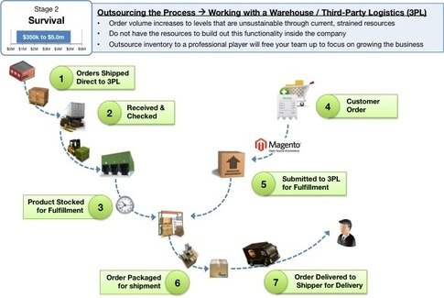

Q-5 What is Flow chart? Create a Flow chart To make Addition of Two Numbers

Ans-> Flow chart is a diagram of the sequence of movements or actions of people or things involved in a complex system or activity.

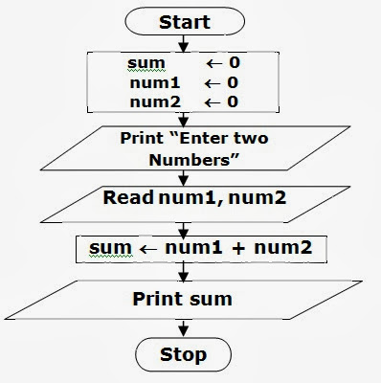

Q-6 What is use case diagram? Create a use-case on bill payment on Paytm.

Ans-> A Use Case diagram **illustrates a set of use cases for a system**, i.e. the actors and the relationships between the actors and use cases. The include relationship adds additional functionality not specified in the base use case.

